**Publish a project**

* Go to UiPath Studio to create a new blank project. The **New Blank Project** window is displayed.
* Click the **Name** field and type a name, such as “OrchestratorHelloWorld”, and then press **Create**.
* Drag and drop a **Message Box** activity to the **Designer** **panel**.
* Click the **Content** field and type any text, such as “Hello UiPath Orchestrator!”.
* Run the process. After the message box appears, press OK to return to Studio. This test is completed.
* Under **Setup,** click **Publish**. A message pops up. It specifies that a package has been published locally (by default, in *C:\ProgramData\UiPath\Packages*).

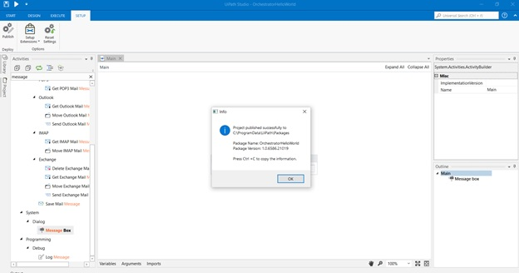

* Navigate to the specified folder in Windows and locate the package.

